# Lab 06 – Data Definition Language

This Lab relates to the following Course Learning Requirements:

CLR 1: Follow lab policies and procedures for etiquette, software licensing requirements and lab submissions

CLR4: Use Data Definition Language (DDL) to add, modify and delete database objects, i.e. tables.

CLR5: Use Data Manipulation Language (DML) to insert, update, select and delete data

Objective:

The objective of this lab is to make sure that you know how to use Data Definition Language .

# Pre-Lab Instructions:

1. Read module 6 and Module 7

**Lab Tasks:**

1. Firstly, import the data (student.sql) in database.
2. Using the different DML commands answer the following questions.
   * SELECT – Number of students enrolled?
   * SELECT WHERE – Number of students in Computer Science Program?
3. Using INSERT add a student George Smith (cell - 887258963) to database who has taken Computer Technician course and is 25 years old and save this SQL as LastName_INSERT.sql
4. UPDATE the course name from Computer Science to Computer Science Engineering for every student enrolled in Computer Science and save the SQL as LastName_UPDATE.sql.
5. DELETE the students Anita Arora and Frank Tribiani and save the SQL as LastName.DELETE.sql.
6. Your lab is to include:
   * MS word for the two questions:
     1. On the header have the course code and course name, the lab number, your student ID, your name, the instructor’s name, and the date the lab is submitted.
     2. Put the question and answer to it.
   * SQL files for INSERT, UPDATE and DELETE statements needed.

NOTE: To save the SQL command. Save the SQL code written to Insert, update and delete in previous steps.

* + Please zip all files and upload to Brightspace

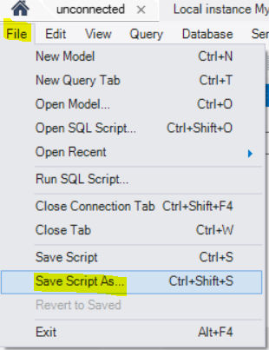

* + 1. LastName_INSERT.sql
    2. LastName_UPDATE.sql
    3. LastName_DELETE.sql

**Lab Grading Rubric (3%)**

|  |  |
| --- | --- |
| Lab Submission (MS word) | /1.5 |
| Lab Submission (SQL) | /1.5 |
| Total Points | /3 |
| Comments |  |